**Appendix A**

1. EER Diagram

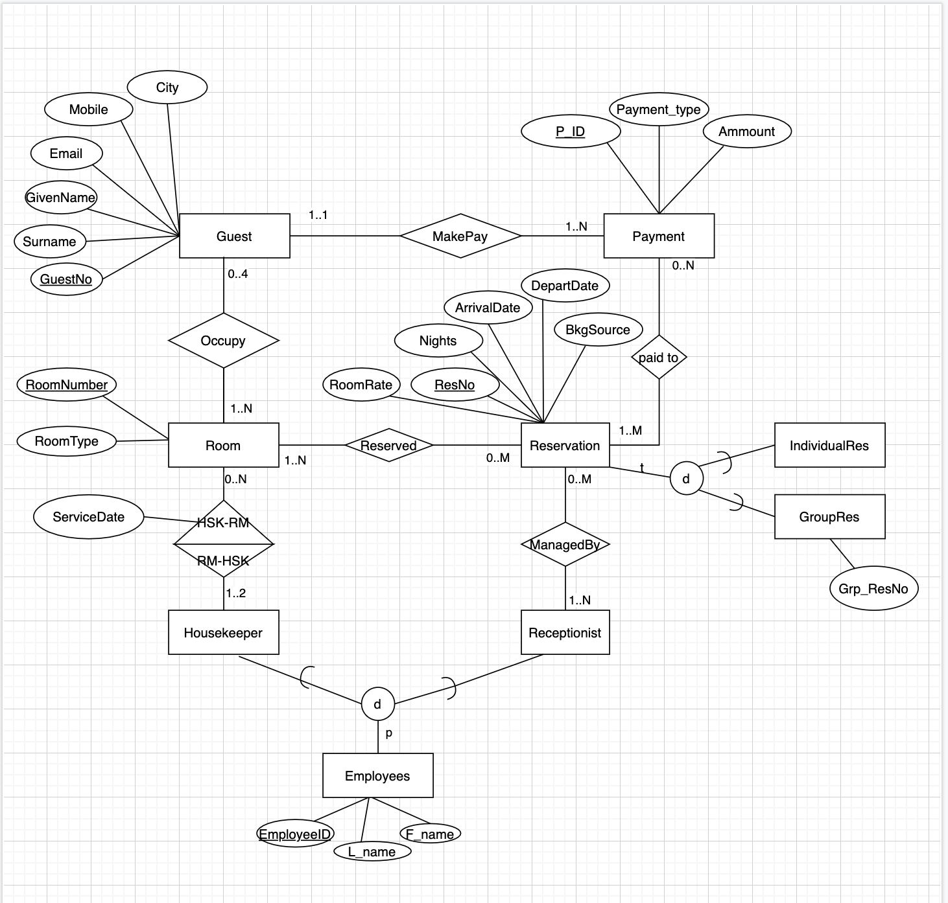

1. UML Diagram

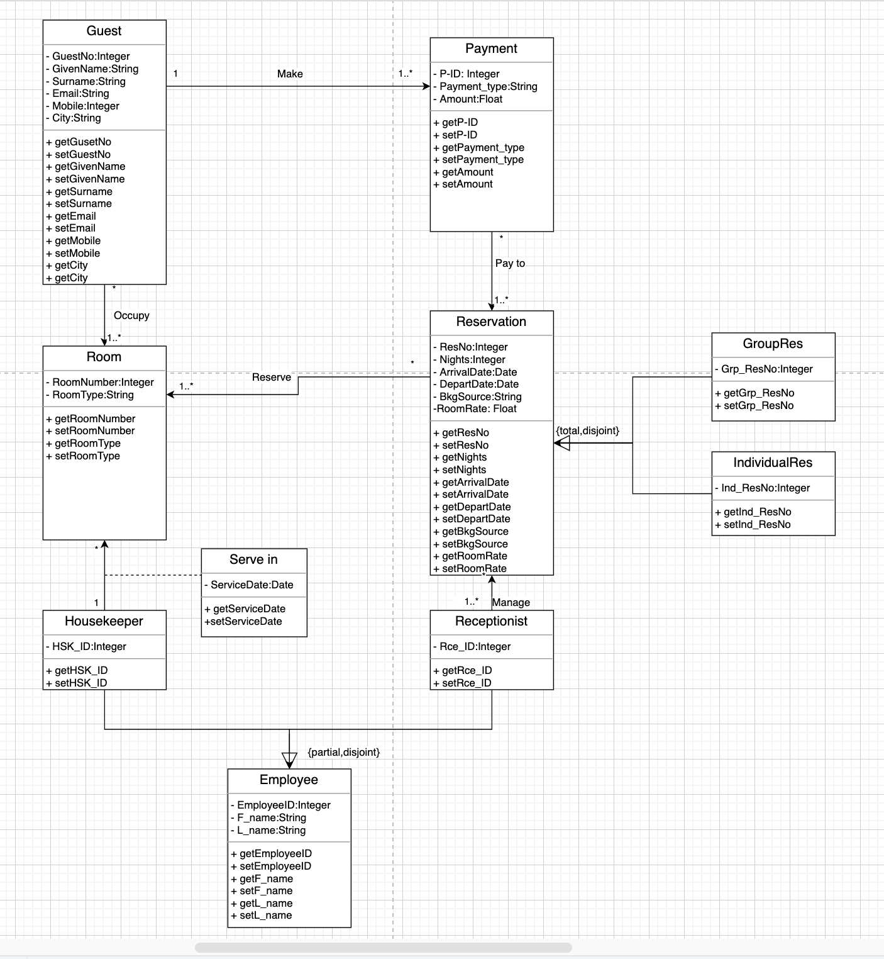

1. Mapping EER to Relational Model

Note: Primary Key are underlined, Foreign key (FK) are italics.

**Guest**(GuestNo, Surname, GivenName, Email, Mobile, City)

**Room**(RoomNumber, RoomType)

**Occupy**(GuestNo, RoomNumber)

GuestNo: is the FK refers to GuestNo in the relation Guest, Null not allowed, update/delete cascade.

RoomNumber: is the FK refers to RoomNumber in the relation Room, Null not allowed, update/delete cascade.

**Payment**(P_ID, Payment_type, Amount, P_GuestNo)

P_GuestNo: is the FK refers to GuestNo in relation Guest, Null not allowed, update/delete cascade.

**Paid to**(P_ID, ResNo)

P_ID: is the FK refers to P_ID in relation Payment, Null not allowed, update/delete cascade.

ResNo: is the FK refers to ResNo in the relation Reservation, Null not allowed, update/delete cascade.

**Reservation**(ResNo, ArrivalDate, DepartDate, Nights, BkgSource, RoomRate)

**IndividualRes**(Ind_ResNo)

Ind_ResNo: is the FK refers to the ResNo in the relation Reservation, Null not allowed, update/delete cascade.

**GroupRes**(Grp_ResNo, Separate_ResNo,)

Separate_ResNo: is the FK refers to the ResNo in the relation Reservation, Null not allowed, update/delete cascade.

**Reserved**(RoomNumber, ResNo)

RoomNumber: is the FK refers to RoomNumber in the relation Room, Null not allowed, update/delete cascade.

ResNo: is the FK refers to ResNo in the relation Reservation, Null not allowed, on update/delete cascade.

**Employees**(EmployeeID, L_name, F_name)

**Housekeeper**(HSK_ID)

HSK_ID: is the FK refers to EmployeeID in relation Employees, Null not allowed, on update/delete cascade.

**Receptionist**(Rec_ID,...)

Rec_ID: is the FK refers to EmployeeID in the relation employees, Null not allowed, on update/delete cascade.

**RoomService**(HSK_ID, RoomNumber, ServiceDate)

HSK_ID: is the FK refers to HSK_ID in relation Housekeeper, Null not allowed, update/delete cascade.

RoomNumber: is the FK refers to the RoomNumber in the relation Room, Null not allowed, update/delete cascade.

**ManageReservation**(Rec_ID, ResNo)

Rec_ID: is the FK refers to Rec_ID in the relation Receptionist, Null not allowed, update/delete cascade.

ResNo: is the FK refers to ResNo in the relation Reservation, Null not allowed, update/delete cascade.